THE IDIOSYNCRATIC

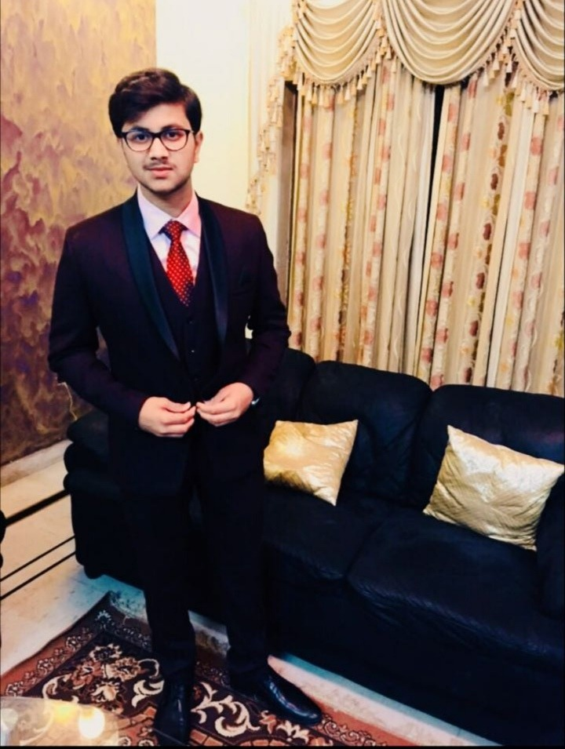

#### Background :

My name is Abhishek Srivastava and I was born on the 29th of September, 2000 in Lucknow, India. My parents were Amitabh Srivastava and Amita Srivastava. Since childhood, I was a coddled child and because of being the youngest of three, I was embraced the most among my siblings. I have grown up in a joint family and amidst my cousins who always support and cared a lot about me.

#### Educational Phase :

I attained my education from St. Francis' College, Lucknow. Studied there for fourteen years made me feel a Sence of Belongingness with that place, A place where a had the best memories of my life. Friends whom I count as my family members, Numerous achievements in sports and academics which always tends to hoist my self-confidence, and teachers who guided me through the unrelenting difficulties of my life. I was among the ablest students of my school and had an outstanding result in my matriculation and Higher Secondary Science. A further pursued Btech in Computer Engineering at Vellore Institute of Technology.

**Approach to Life :**

I'm an Introvert with a pinch of altruism, who is always on the verge to help others. I'm a benefactor who believes in improvement through collaboration rather than competition. I do not depend on others for happiness as I have a firm belief that every individual is in itself a source of happiness. Everyone has a motivation for their dreams and my motivation is my Father.

**Long Term Goal:**

My long Term goal is not to be a researcher in Quantum Computing Field, or an Entrepreneur, or a Software Engineer but is to a Human who can set an example for others who are ensnared in their life. "I do not demand an improvement, I want a revolutionary change in the World."